**1. Deploy a sample HTML website in any apache container, and demonstrate how we can**

**dynamically change content in the container by making changes on the host machine ( Bind**

**Mounts)**

1 sudo apt-get update

2 sudo intall apt docker.io

3 sudo intall apt-get docker.io

4 sudo install apt-get docker.io

5 sudo install apt docker.io

6 sudo apt install docker.io

7 sudo docker run -it -d -p 80:80 ubuntu

8 sudo docker exec -it d8ec88fcd355cc9715b19d6adc69013c16e17025b979469d0c914874da6cdf23 bash

9 ls

10 mkdir html

11 ls

12 cd html

13 docker run –it –v /home/ubuntu/html:/var/www/html –d d8ec88fcd355

14 docker run –it –v /home/ubuntu/html:/var/www/html –d creamcode/apache

15 sudo docker run –it –v /home/ubuntu/html:/var/www/html –d creamcode/apache

16 sudo docker run –it –v home/ubuntu/html:/var/www/html –d creamcode/apache

17 docker run --help

18 sudo docker run –it –v home/ubuntu/html:/var/www/html –d creamcode/apache

19 sudo docker run –it –v /home/ubuntu/html:/var/www/html –d creamcode/apache

20 sudo docker run –it –v /home/ubuntu/:/var/www/html –d creamcode/apache

21 sudo docker run –it –v /home/ubuntu/:/var/www/ –d creamcode/apache

22 sudo docker run –it –v /home/ubuntu/:/www/ –d creamcode/apache

23 sudo docker run –it –v /home/ubuntu/:/app –d creamcode/apache

24 sudo docker run –it –v /home/ubuntu/:/app –d ubuntu

25 docker run -it -d ubuntu

26 sudo docker run -it -d ubuntu

27 sudo docker run -it -v /home/ubuntu:/app -d ubuntu

28 sudo docker run -it -v /home/ubuntu:/app -d creamcode/apache

29 sudo docker run -it -v /home/ubuntu/html:/app -d creamcode/apache

30 sudo docker run -it -v /home/ubuntu/html:/var/www/html -d creamcode/apache

31 sudo docker rm $(sudo docker ps -a -q)

32 sudo docker rm -f $(sudo docker ps -a -q)

33 ls

34 sudo docker run -it -v /home/ubuntu/html:/var/www/html -d creamcode/apache

35 ls

36 nano 1.html

37 docker ps

38 sudo docker ps

39 sudo docker run -it -p 80:80 -v /home/ubuntu/html:/var/www/html -d creamcode/apache

40 sudo docker ps

41 docker rm cbb48d8205cc

42 sudo docker rm cbb48d8205cc

43 sudo docker rm -f cbb48d8205cc

44 docker ps

45 sudo docker ps

46 sudo docker exec -it 7c91ba86eb02

47 sudo docker exec -it 7c91ba86eb02 bash

48 history

1 apt-get update

2 apt get-install apache2

3 apt-get install apache2

4 service apache2 status

5 service apache2 start

6 service apache2 status

7 docker ps

8 exit

9 ls

10 service

11 service --status-all

12 service apache2 status

13 service start apache

14 service start apache2

15 systemctl start apache2.service

16 service apache2 start

17 history

**2 Deploy apache and nginx containers using Docker Compose, Apache should be exposed on**

**Port 91 and nginx on port 92**

1 sudo apt-get update

2 sudo intall apt docker.io

3 sudo intall apt-get docker.io

4 sudo install apt-get docker.io

5 sudo install apt docker.io

6 sudo apt install docker.io

7 sudo docker run -it -d -p 80:80 ubuntu

8 sudo docker exec -it d8ec88fcd355cc9715b19d6adc69013c16e17025b979469d0c914874da6cdf23 bash

9 ls

10 mkdir html

11 ls

12 cd html

13 docker run –it –v /home/ubuntu/html:/var/www/html –d d8ec88fcd355

14 docker run –it –v /home/ubuntu/html:/var/www/html –d creamcode/apache

15 sudo docker run –it –v /home/ubuntu/html:/var/www/html –d creamcode/apache

16 sudo docker run –it –v home/ubuntu/html:/var/www/html –d creamcode/apache

17 docker run --help

18 sudo docker run –it –v home/ubuntu/html:/var/www/html –d creamcode/apache

19 sudo docker run –it –v /home/ubuntu/html:/var/www/html –d creamcode/apache

20 sudo docker run –it –v /home/ubuntu/:/var/www/html –d creamcode/apache

21 sudo docker run –it –v /home/ubuntu/:/var/www/ –d creamcode/apache

22 sudo docker run –it –v /home/ubuntu/:/www/ –d creamcode/apache

23 sudo docker run –it –v /home/ubuntu/:/app –d creamcode/apache

24 sudo docker run –it –v /home/ubuntu/:/app –d ubuntu

25 docker run -it -d ubuntu

26 sudo docker run -it -d ubuntu

27 sudo docker run -it -v /home/ubuntu:/app -d ubuntu

28 sudo docker run -it -v /home/ubuntu:/app -d creamcode/apache

29 sudo docker run -it -v /home/ubuntu/html:/app -d creamcode/apache

30 sudo docker run -it -v /home/ubuntu/html:/var/www/html -d creamcode/apache

31 sudo docker rm $(sudo docker ps -a -q)

32 sudo docker rm -f $(sudo docker ps -a -q)

33 ls

34 sudo docker run -it -v /home/ubuntu/html:/var/www/html -d creamcode/apache

35 ls

36 nano 1.html

37 docker ps

38 sudo docker ps

39 sudo docker run -it -p 80:80 -v /home/ubuntu/html:/var/www/html -d creamcode/apache

40 sudo docker ps

41 docker rm cbb48d8205cc

42 sudo docker rm cbb48d8205cc

43 sudo docker rm -f cbb48d8205cc

44 docker ps

45 sudo docker ps

46 sudo docker exec -it 7c91ba86eb02

47 sudo docker exec -it 7c91ba86eb02 bash

48 history

49 sudo curl -L "https://github.com/docker/compose/releases/download/1.23.1/dockercompose-$(uname -s)-$(uname -m)" -o /usr/local/bin/docker-compose

50 cd ..

51 sudo curl -L "https://github.com/docker/compose/releases/download/1.23.1/dockercompose-$(uname -s)-$(uname -m)" -o /usr/local/bin/docker-compose

52 sudo chmod +x /usr/local/bin/docker-compose

53 mkdir docker

54 cd docker

55 nano docker-compose.yml

56 docker-compose up –d

57 sudo curl -L "https://github.com/docker/compose/releases/download/1.23.1/dockercompose-$(uname -s)-$(uname -m)" -o /usr/local/bin/docker-compose

58 sudo chmod +x /usr/local/bin/docker-compose

59 docker-compose up –d

60 pwd

61 sudo curl -L "https://github.com/docker/compose/releases/download/1.23.1/docker-compose-$(uname -s)-$(uname -m)" -o /usr/local/bin/docker-compose

62 sudo chmod +x /usr/local/bin/docker-compose

63 docker-compose up –d

64 nano docker-compose.yml

65 docker-compose up –d

66 nano docker-compose.yml

67 docker-compose up –d

68 nano docker-compose.yml

69 y

70 nano docker-compose.yml

71 docker-compose up –d

72 nano docker-compose.yml

73 docker-compose up –d

74 nano docker-compose.yml

75 docker-compose up –d

76 docker-compose --version

77 sudo docker rm -f $(sudo docker ps -a -q)

78 docker-compose up –d

79 sudo docker-compose up –d

80 sudo docker-compose up

81 nano docker-compose.yml

82 sudo docker-compose up

83 nano docker-compose.yml

84 sudo docker-compose up

85 nano docker-compose.yml

86 sudo docker-compose up

87 nano docker-compose.yml

88 sudo docker-compose up

89 sudo docker-compose up -d

90 nano docker-compose.yml

91 sudo docker-compose up -d

92 history

docker-compose.yml

version: '3'

services:

sample1:

image: 'httpd'

ports:

- "91:80"

sample2:

image: 'nginx'

ports:

- "92:80"

**3. Initialize a Docker Swarm Cluster, and deploy two ubuntu containers in a overlay network.**

**Demonstrate they can communicate with each other, by pinging them**

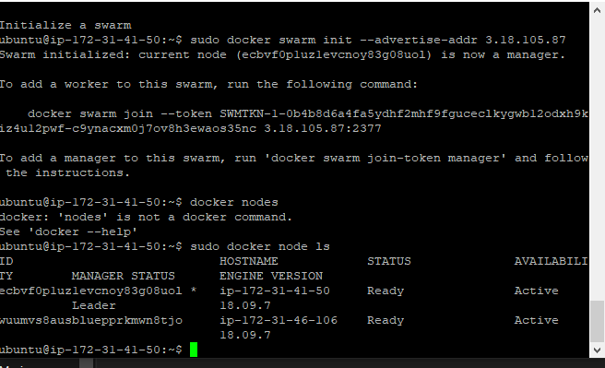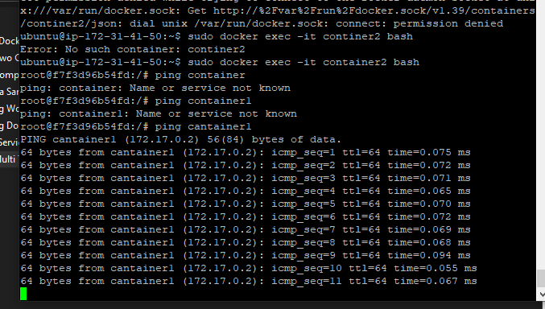

1 sudo apt-get update

2 sudo apt install docker.io

3 sudo docker swarm init –advertise-addr 3.18.105.87

4 sudo docker swarm init --advertise-addr 3.18.105.87

5 docker nodes

6 sudo docker node ls

7 sudo docker run -it --name cantainer1 -d ubuntu

8 docker run -it --name container2 --link cantainer1 -d ubuntu

9 sudo docker run -it --name container2 --link cantainer1 -d ubuntu

10 docker exec -it container2 bash

11 sudo docker exec -it container2 bash

12 sudo docker ps

13 sudo docker ps -a

14 sudo docker ps -l

15 ping continer1

16 sudo exec -it continer2 bash

17 ping 192.168.0.0

18 sudo continerexec -it continer2 bash

19 sudo continerexec -it continer2 bashsudo

20 sudo docker exec -it continer2 bash

21 docker exec -it continer2 bash

22 sudo docker exec -it continer2 bash

23 sudo docker exec -it container2 bash

24 history